Name & Student ID: Ethan Blagdon 20553776

2 Axis Robot Writer Project

Software Description
The code writes and receives data from the Arduino to a 2 axis robot which writes text on a page. The Robot "writes" from G code inputs sent by the Arduino. 1 word is processed at a time and when the robot is ready to receive the next word it sends data to the Arduino requesting more data.
- Open and read a txt file containing font data
- Get a user input for the font size between 4 and 10
- Scale the GCode data that will be sent to the robot with the font size (user inputted value/10)
- Store the GCode data locally so it is all in memory, with each letter being able to be accessed separately using a struct with an array for each character.
- Open a txt file containing the words to be written
- Find how many word are in the document and read and store the first word
- Set the initial conditions for the robot (x=0 y=0 and pen up) and send them to the robot
- For each word, The x and y starting positions determined (if the word length + current words in line are greater than the maximum x space on page a new line is made and the word starts on the new line (change in y)) (x position is then determined as if its on a new line it is 0 and if its carrying on from the last word it is the ending x point of the last word plus a gap)
For each letter:
a. The character is read and the Gcode in Letters[] for the character is found
b. From the x and y starting point the Gcode is loaded in from the file and the x and y starting positions are added to all lines of the code for that character.
c. for the number of rows of Gcode for the letter the GCode is sent line by line with X Y and P positions
d. The x starting point adds on the width of the character processed.
After all letters in the word are complete, The next Word is then read from the txt file and saved in separate columns of an array WordContents().
- After all words are complete and the text file has reached the end, the pen is set to the up position and is sent to 0,0. Then turn off the robot.
- Terminate the program
Throughout the program there are also error checks for files failing to open, reaching the end of font files, not connecting to the robot and reading corrupted font data. Aswell as ensuring the user inputs a correct sized font and ensuring the words to be written fit on the page by themselves (no very long words).
Here is an example of the emulator output for “The quick brown fox jumped over the lazy dog” in font size 5. Not it does not track the up and down pen positions.
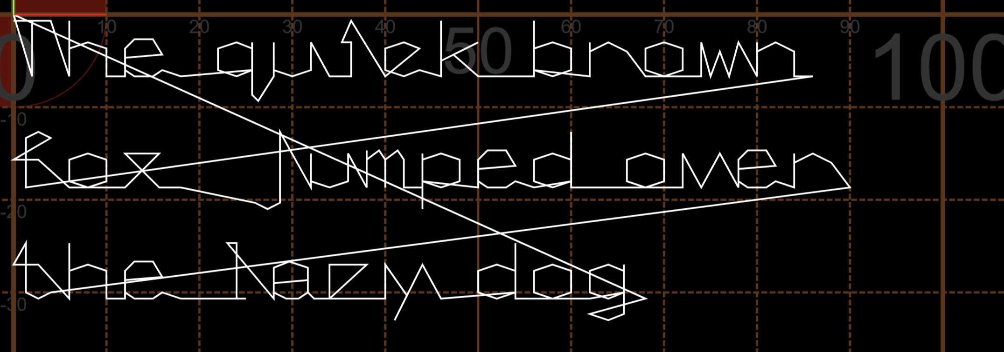

Project Files
(Maximum 1 page)
The Project uses 7 created files (3 .h files to link the 4 .c files together), 4 premade files to communicate with the Arduino (rs232 and serial .c and .h) and 2 txt files, one containing the font data and 1 containing the word to be written called test.txt. .c files contain the code in functions and the .h files contain the instructions to link the .c files to the main function to execute the code.
The Created files are below:
CharacterToGCode.c and .h
This file contains 3 functions which are used to alter or send GCode lines. It has the function FindWordSpacing which finds characters spacings too apply to GCode, GCodeToRobot which sends the GCode stored in the letters arrays to the sendcommands function, and the SendCommands function, a pre made function which sends the string to the robot.
FormatFont .c and .h
This file contains the function to store and format the font by applying the font size to each line of GCode. This is stored in a struct with each letter having its own array.
FormatWord .c and .h
This file contains the function relating to full words. It has the ReadWord function in it which reads the contents of a word and stores the characters in an array.
Main .c
This file compiles all the functions together and executes the instructions to form the program which is explained above. The only function in this file is main().

The layout clearly shows which section is to be worked on to change each piece, with the Font formatting, Word processing and Gcode altering occurring in different files. 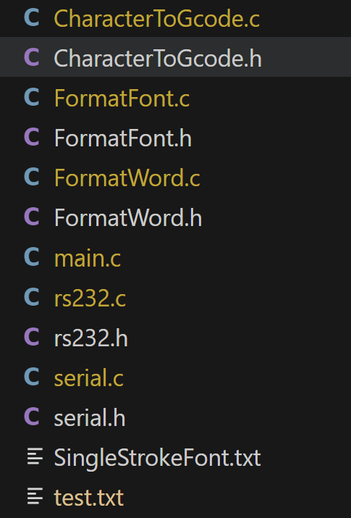
To edit the word to be written, the test.txt document should be changed with the text to be written placed inside.

Key Data Items

Name | Data type | Rationale
Arrays and structures
WordContents() | Char Array | Breaks down the words in the text to individual characters, then stores each character on a separate row so the code has easy access to which character it needs to process in the word read.
Spacing() | Float array | Contains the X and Y spacings for each character to begin printing at. It is updated in positioning after every letter and word.
CharacterFontData | Struct | Structure that holds all font GCode within the Letters arrays, with 1 array for each character
Letters() | Float array | Holds the font Gcode for a character, with 3 columns for the x y and p positions of the pen and however many rows for the given character.
Character formatting, locating and finding
FontSize | Integer | User inputted font size to alter the GCode to size
SpaceBetweenWords | float | Holds the space between words based on the font size to separate words
startposition | integer | Holds the location of the first position to read the next word, so only 1 word is read at a time before being processed.
currChar | char | Holds the current character in the file before being converted into an ascii value or to compare to ‘ ‘ to see if the word has ended.
WordLength | integer | Determines the number of characters in the word to be used later in loops for printing letters
numwords | integer | Holds the number of words in the text file to be used in a for loop to process all words
asciiValue | Integer | Holds the ascii value for the character to be printed which is used to locate the character GCode in the ascii code position in the Letters struct.
Font Data Processing
CharLinesofGCode | Integer | Stores the number of lines of GCode for each character, so the loop to read and store GCode data stops at the correct point.
location | integer | Used to increment the location of the GCode lines to store in the struct
Robot Pen Controls
pen | Integer | States current position of pen (1 is up and 0 is down) used for sending G code to remove unnecessary callouts to lower / raise pen when it is already in that state
x | Float | X position of the pen for each section of Gcode
y | Float | Y position of the pen for each section of Gcode

Function
Only include functions that you have written yourself.
int GCodeToRobot(CharacterFontData (*Letters)[], int asciiValue, float Spacing[], char buffer[]);
The Function takes in the ascii Value for the letter it has to write and converts the character to GCode using the letters struct, then sends all the lines of GCode to the robot through the buffer function.
Parameters:
Struct CharacterFontData (*Letters)[]– Inputs a pointer to the FontData struct with all the GCode for characters in to use to send to the robot
Integer asciiValue – inputs the ascii value of the character to be sent to eth robot which wil be used to find the GCode in Letters
Float array Spacing[] – inputs the Spacings for the character to be printed so it is placed after the last character, or if a new word a space between the last word
Function Buffer[] – output function to send the GCode to the Robot via serial
Return value – returns 0 is successful, 1 if failed

int FindWordSpacing(CharacterFontData (*Letters)[], char WordContents[], float (*Spacing)[], int FontSize);
The function finds the spacings required for the start of each word to then apply to the characters of the next word, taking into account the length of the word, position of the last word and the space between words
Parameters:
Letters – Inputs the GCode for X and Y spacings from SingleStrokeFont to add to word spacings
Struct CharacterFontData (*Letters)[] – Inputs the contents of the current word which will be used to determine if the word will fit on the current line written on
Character array *Spacing – Inputs and outputs a pointer to the spacing array to determine the new words initial spacing (based on last words final spacing) and output the new X and Y spacing.
Integer FontSize – inputs the font size to scale to the words number amount to determine the size of the word to determine spacings.
Return value – returns 0 is successful, 1 if failed

int FormatAndScaleFontData(FILE *SingleStrokeFont, int FontSize, CharacterFontData (*Letters)[]);
The Function formats and scales the font data from the txt file to a struct, with the font size applied. Each character has its own array which stores its x y and p positions for each step of GCode.
File *SingleStrokeFont – inputs a pointer to the Font data to be stored in the Letters array
Integer FontSize – inputs the font size to scale the font data to apply the correct font size to all GCode which is stored in Letters[]
Struct CharacterFontData (*Letters)[] – inputs a pointer which is used to output the stored and scaled GCode for the rest of the program to use.
Return value – returns 0 is successful, 1 if failed

int ReadWord(FILE *WordFile, char (*WordContents)[], int *startposition);
The function reads the next word and stores the characters of the word in an array which is used to send to the GCodeToRobot function. This ensures the text is only processed 1 word at a time.
FILE *WordFile – inputs a pointer to the Word file with the text to be written which is used to find the characters in a given word
Character array *WordContents – inputs a pointer which is used to output the characters in 1 word , stored in an array which is used in the main program
Integer *startposition – inputs a pointer which is used to determine the line to start reading from in the word file and then output the new start point for the next word after the current word has be read to be used next time the function is called.
Return value – returns 0 is successful, 1 if failed

Testing Information
Function | Test Case | Test Data | Expected Output
Main() | 1. No robot connected  2. font size is not between 4 and 10  3. Font File missing  4. text file missing  5. normal operation | 1. Disconnect robot from Arduino  2. User input font size of 11 and test again with font size of 2  3. Delete Font file  4. Delete text file  5. All files and data inputted correctly (font between 4 and 10) (test.txt) | 1. Error reported and terminate code  2. States error and asks user to reinput font. Code does not stop  3. Error reported during compilation and stops  4. Error reported during compilation and stops  5. Robot prints the data in the test.txt
GetCharLocation() | 1. Normal operation | *SingleStrokeFont.txt | Every time 999 is read from font data the line location is written in a new column in CharLocation()
FormatAndScaleFontData() | 1. Normal Operation | *SingleStrokeFont.txt and user inputted font size (pre checked) | The scaled Gcode data is stored in the array CharGCode()
SeperateWords() | 1. Normal Operation | Test.txt containing:  “Test of Word  Saving” | The WordContents() array contains all the characters in test.txt with letters in the same word separated along columns and different words separated along rows. Should look like this 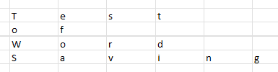
WordToGCodeandSend() | 1. Normal Operation  2. Word length too long | WordContents(). For 1.  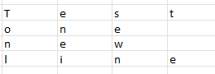  For 2: | 1. Each letter of each word should be sent to robot in G code and only send data when the robot asks for it. Words do not run off page  2. Error when processing data and program stops as it cannot fit onto the page
SendToRobot() | 1. Correct GCode  2. CorruptedGcode (wrong format) | CurrentCharacterGCode()  (case 1 use test.txt, case 2 change a pen position number to non Boolean (7)) | 1. Robot receives all data and “writes” the GCode in CurrentCharacterGCode()  2. Error displays in code and code stops on line
Extend table as required. Note that ‘Function’ includes main()

Flowchart(s)
The Flowcharts are included in separate PDF’s

AI Statement
No AI was used in the submission

